**Basic Tasks**

# **Difference b/w UI and UX:**

## **UI (User Interface):**

The **look and layout** of an app or website.

* What buttons look like, colors, fonts, icons, etc.
* It’s like the makeup of the app.

To make the idea clear, think of constructing a house. UI in the house would be colors of the paint on the walls, the designing of the doors and windows, the ceiling designs, designs of the lamps and lights etc.

## **UX (User Experience):**

How the **user feels** when using the app.

* Is it easy to use? Intuitive? Frustrating?
* Example: If a food delivery app takes too many steps to order food, that’s bad UX even if it looks great.

If we take the house example again, UX there would be the position of the walls, place where door and windows would be placed, would there be ceiling or not, where the lamps and lights would be placed etc.

# **Usability principles:**

1. **Consistency** – Keep things uniform.

* Buttons should behave similarly throughout the app.
* Example: A back arrow should always go back.

2. **Simplicity** – Less is more.

* Don’t overload the user with options or visuals.
* Use clear labels like “Sign Up” instead of “Initiate Registration Process”.

3. **Feedback** – Let the user know what’s happening.

* Show a loading spinner, confirmation message, etc.
* Example: "Message sent!" after hitting send.

4. **Visibility** – Important things should be easy to find.

* Key actions like “Buy Now” should stand out.
* Don’t hide important features behind too many clicks.

# **Design thinking:**

## **Definition:**

A process to solve problems *from the user's perspective.*

* Steps: *Empathize → Define → Ideate → Prototype → Test*
* You're not just designing screens—you’re solving real user problems.

## **Double Diamond:**

Visual model of creative problem solving.

* 2 diamonds:
  + **Discover & Define** (understand the problem)
  + **Develop & Deliver** (find and build the solution)

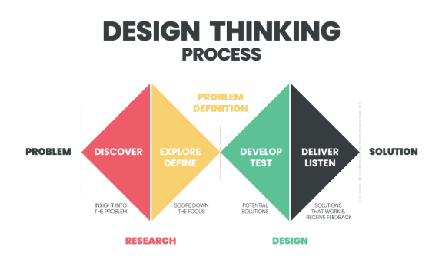

**Design Tools Setup:**

## **Figma (Main tool):**

Free and browser-based design tool. Super popular for UI/UX.

* You can design screens, make prototypes, and collaborate.
* Learn:
  + **Frames** = like artboards (screens)
  + **Components** = reusable UI parts (like buttons)
  + **Layers** = everything you add is a layer
  + **Grids** = help with alignment and spacing

**Visual Design Basics:**

* **Typography** – Font choices and sizes (like bold for titles).
* **Spacing & Alignment** – Use even gaps and align elements properly.
* **Color Theory** – Use matching color palettes. Don’t use clashing or too many colors.
* **Visual Hierarchy** – Make important things stand out.

**Recreation of app’s designs:**

**WhatsApp:**

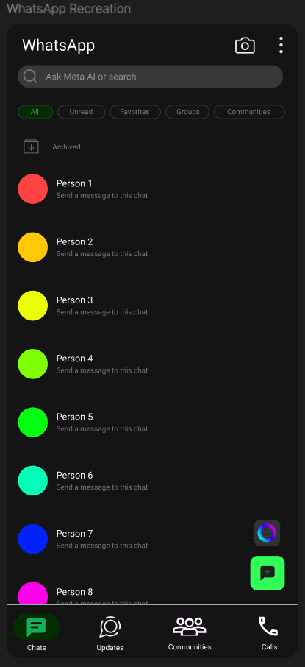

**YouTube:**

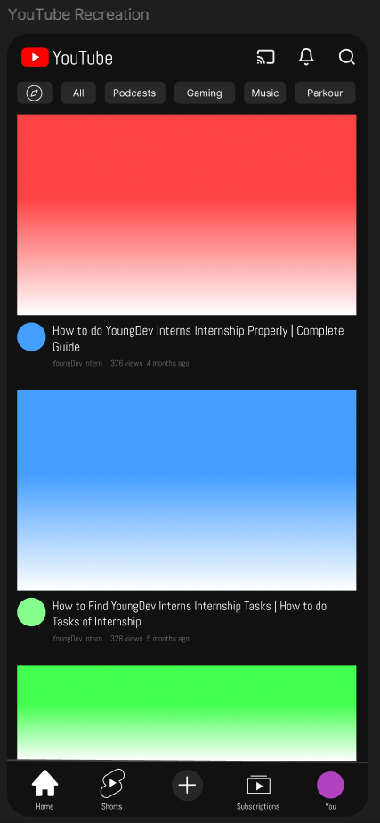

**Spotify:**

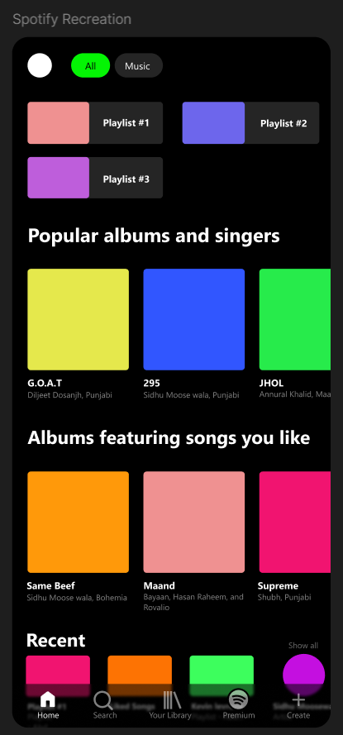

**YT Music:**

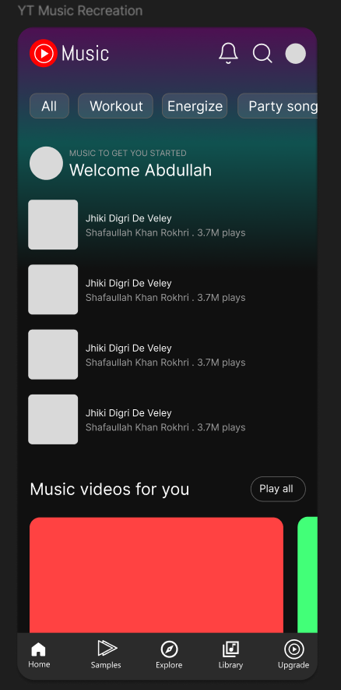

**Wireframe:**

